20.35: a) No; the velocity distribution is a function of the mass of the particles, the number of particles and the temperature, none of which change during the isothermal expansion. b) As in Example 20.11, 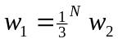(the volume has increased, and 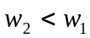); 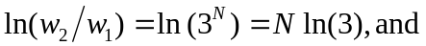
c) As in Example 20.8, 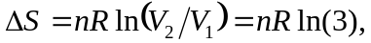the same as the expression used in part (b), and 